20111146 Ibukun Oreofe Bello and 20110307 Huseyin Özdemir Kulaoğlu

Department of  Computer Engineering

[Github user manual]

**GitHub**

***GETTING ON WITH VERSION CONTROL SYSTEM***

**TABLE OF CONTENTS**

**Page**

1.0) Creating an Account on GitHub............................. .. 2

1.1) Creating and Configuring Repository....................... 2

2.0) GitHub Installation .................................................. 4

3.0) Working on Repository Using Command Line………. 5

3.1) Cloning a Repository ............................................... 6

3.2) Editing Repository Contents ................................... 7

3.3) Working With Repository Using GUI……………………. 9

1. **Creating an Account on GitHub**

First of all, you will need to go to “[*https://github.com/*](https://github.com/)” web page. After visiting this web page, you are going to see sign up and sign in options at the top right corner of the GitHub web page. In order to create an account, sign up option must be selected. Having done this, you should see the page as the same as given below.

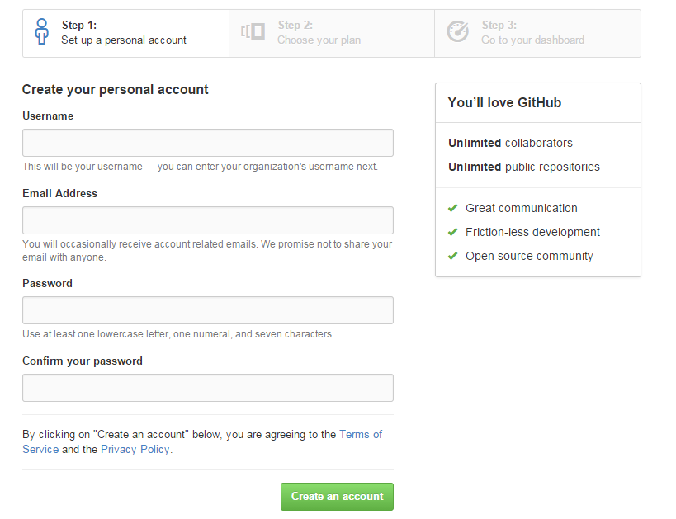

Figure 1.0 : Create an Account on GitHub

In username field, your name can be entered or whatever you like. In email address field, frequently used mail address must be entered and you must choose strong, unforgettable password and it must be entered password and confirm your password fields as the shown in Figure 1.0 . When you complete this task, you must choose create an account, and email account will be checked to validate your mail address to ensure that your account. Now you are ready to use the GitHub as an online. In order to be log in to GitHub system, at the top right corner sign in option must be selected. Then username and password must be entered to enter the GitHub account.

1.1) **Creating and Configuring Repository**

After entering the GitHub account, you will see your username at the top right corner of the web page. Beside of the username, plus sign must be selected and it will show two menu which are “*New Repository*” and “New Organization” as shown in Figure 1.1 . In order to create the repository, “*New Repository*” option must be selected. Having done this, you will see the page as the shown in the Figure 1.1 .

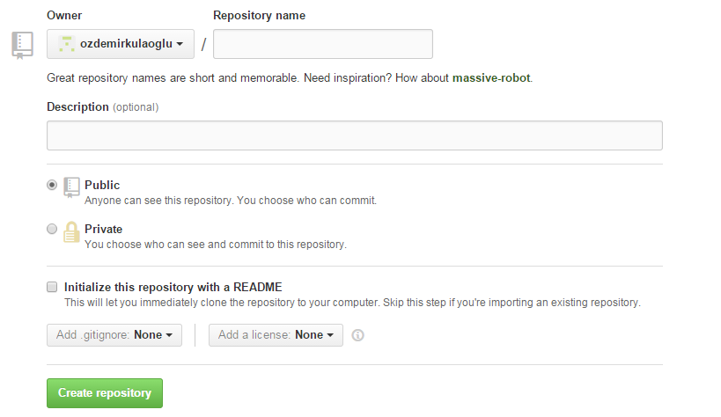

Figure 1.1 : Creating and Configuring Repository

In repository name section, meaningful name must be put like a project name. In description part, the user may enter a sentence to describe the repository if the user would like to do it. Otherwise, this part can be leave empty.

There are 2 options under the description part:

* Public means that, created repository is going to be visible for everyone. So that people can make any changes on that repository.
* Private means that, created repository is going to be seen by only specific people who are working and eligible to make changes on that repository. But make sure that, this section will be costly for the user.

Therefore one of these options can be selected according to user needs.

After creating the account, it is possible to add any people you want who are going to work in this project. In order to add these people, you need to select new collaborator by selecting the plus sign that is located beside of your username. To understand better please have a look at the Figure 1.1 given below.

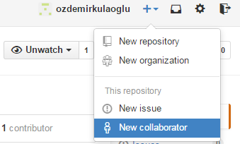

Figure 1.2 : Adding New People to Repository

1. **GitHub Installation**

GitHub has a good feature for software developers which is called computer application software. So this software provides more flexible environment to software developers to be able to share their work with their teammates. In addition, this software can be installed on Windows and Mac OS platforms.

 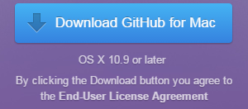

Figure 1.2 : Download GitHub for Windows Platform Figure 1.3 : Download GitHub for Mac Platform

In order to download this software for Windows and Mac platform, you must go to “ https://windows.github.com/ ” and “*https://mac.github.com/*” web page address respectively and click the option as shown in Figure 1.2 and Figure 1.3 .

After completing the downloading procedure on Windows, double click on GitHubSetup.exe installation file. Then application will ask a question like “*Do you want to install this application?*”. Please reply this question by selecting “*Install*” option. Having done this, whole program will be downloaded from the internet. When downloading process completed, two shortcuts of the github will be located on the desktop of your computer which are named as “*GitHub*” and “Git Shell”. Now, you are ready to access your work or repository by using one of these softwares.

1. **Working on Repository Using Command Line**

Created repositories can be seen on the main page of the GitHub web page. To be able to go to main menu, your username must be selected. After completed this step, you will able to see created repositories by you and by another people. In “*popular repositories*” section, you are able to see the repositories that have already created by you. In addition, in “Repositories Contributed to” section, you are able to see the repositories that have already created by another people as shown in Figure 2.1 .

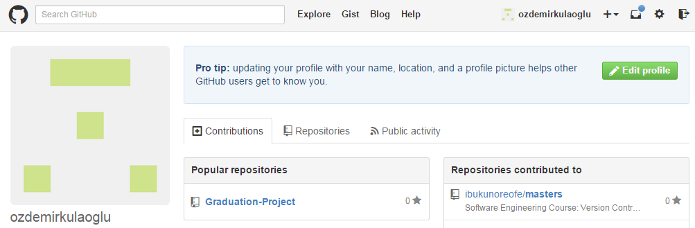

Figure 2.1 : Lists of Repositories

GiTHub installation package comes with an application called “Git Shell” that can be used to perform operations using command line interface.

To begin with, double click the GitHub Application and Login with your github online credentials.

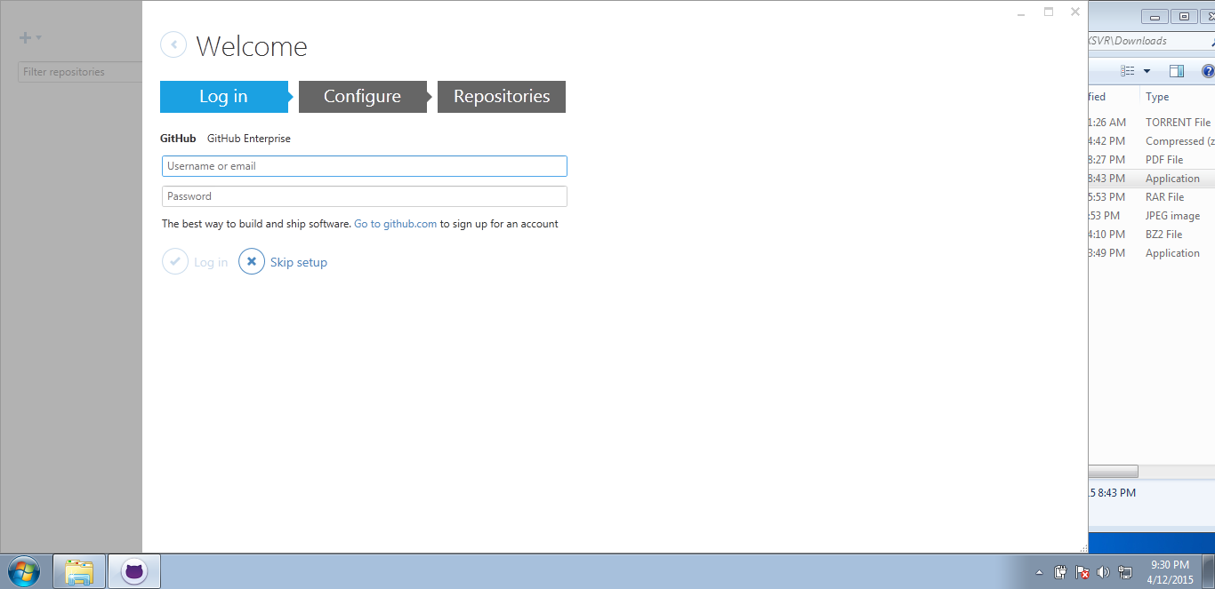

Once you are through with the configuration of your github environment which is simply logging in. Go to desktop and double click the the ***GiT Shell*** Application which should open a command prompt window like the picture below.

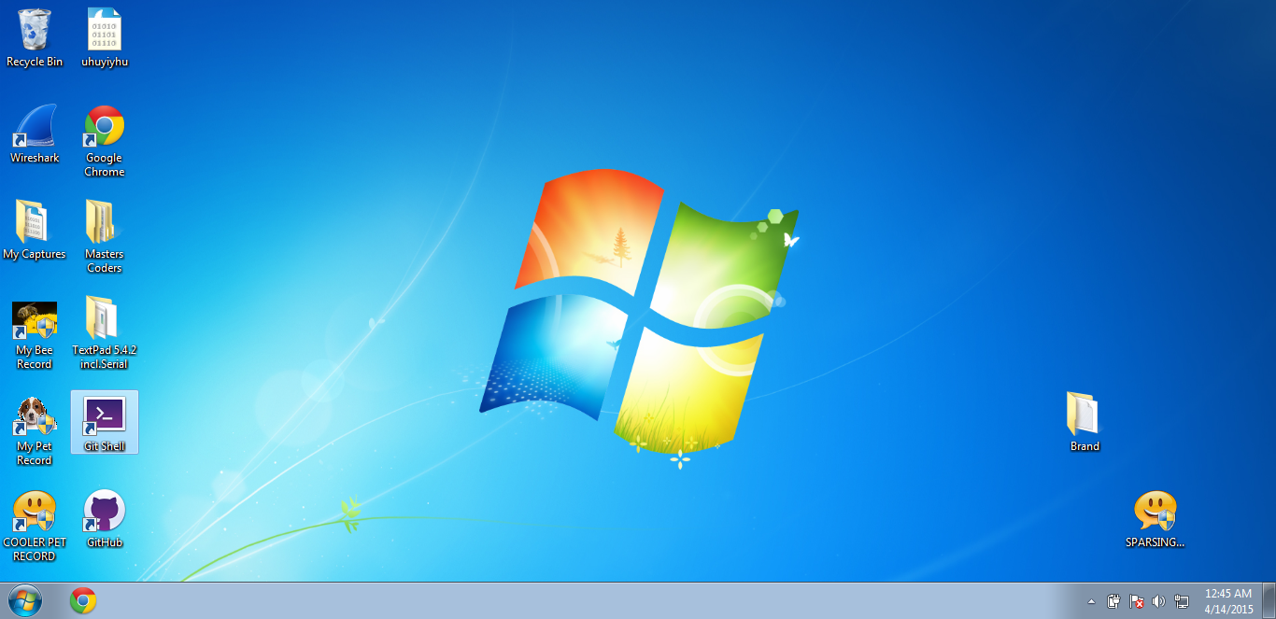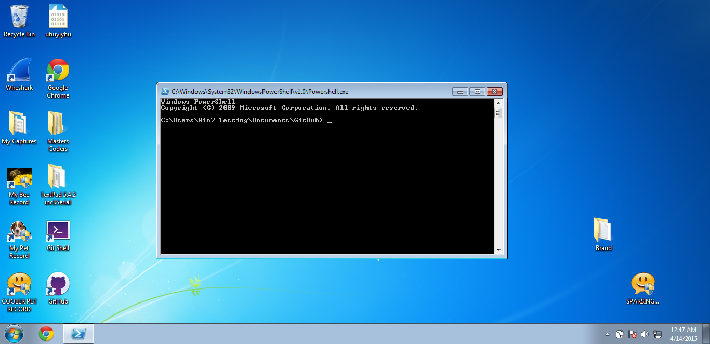

By default it starts command Line Interface and sets its working directory to ***c:\Users\Win7-Testing\Documents\GitHub***

It is simply GiT Hub folder in my documents folder. That is where the repository we are working on will be stored.

3.1) **Cloning a Repository**

After come to this page, one of the repositories must be selected and it will display a new page as shown in Figure 2.2 . At the right bottom corner of the figure, you will see HTTPS clone URL field. Please find this field in your selected repository and select an image that is located beside of the link.

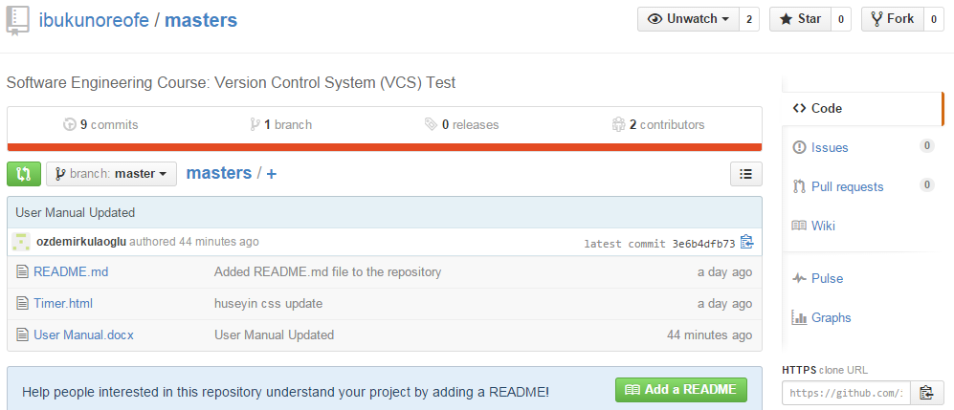

Figure 2.2: Cloning the Repository URL

You can simply click the icon pointed to with the arrow to copy the repository url.

The clone URL in this picture is [***https://github.com/ibukunoreofe/masters.git***](https://github.com/ibukunoreofe/masters.git)

To clone this URL, you will simply type this command on the GiTShell

***git clone URL***

In this case, it will be ***git clone*** [***https://github.com/ibukunoreofe/masters.git***](https://github.com/ibukunoreofe/masters.git)

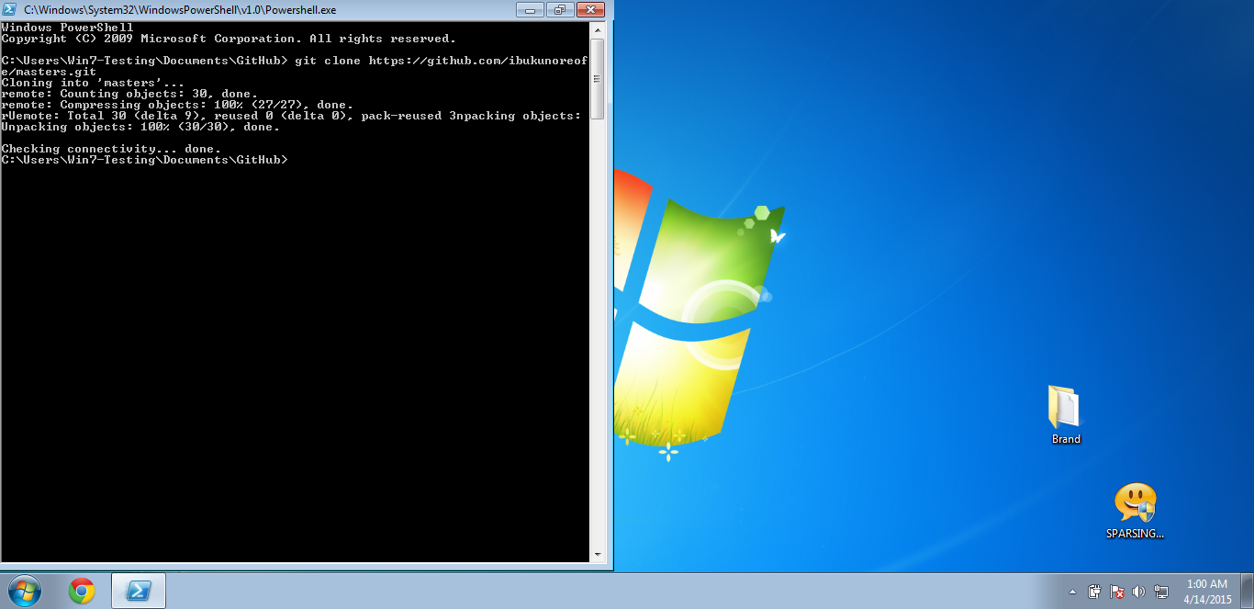

Once that is done, you can navigate into the masters folder created in the GiTHub Directory to view its contents.

To Navigate in command line, type  ***cd masters*** and press enter key.

To List current directory’s content, you can type ***dir*** and press enter key.

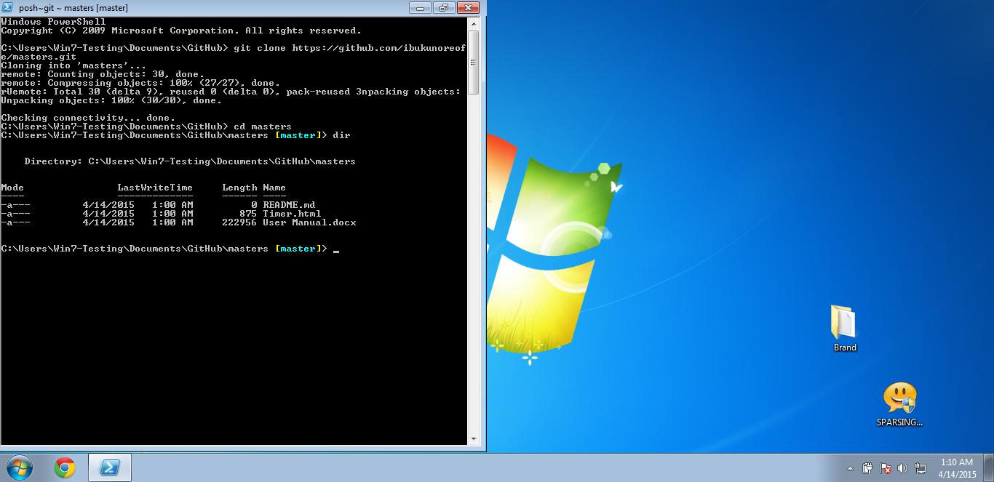

3.2) **Editing Repository Contents**

For this illustration on how to how edit repository items and make the updated version visible to others, we have created ***Timer.html*** file into our repository.

It is a simple system clock application done by 2 team members. One writing the html code and the javascript part while the other is styling the html page to look beautiful. While both are working at the same time, they can see changes made on the same file they are working on.

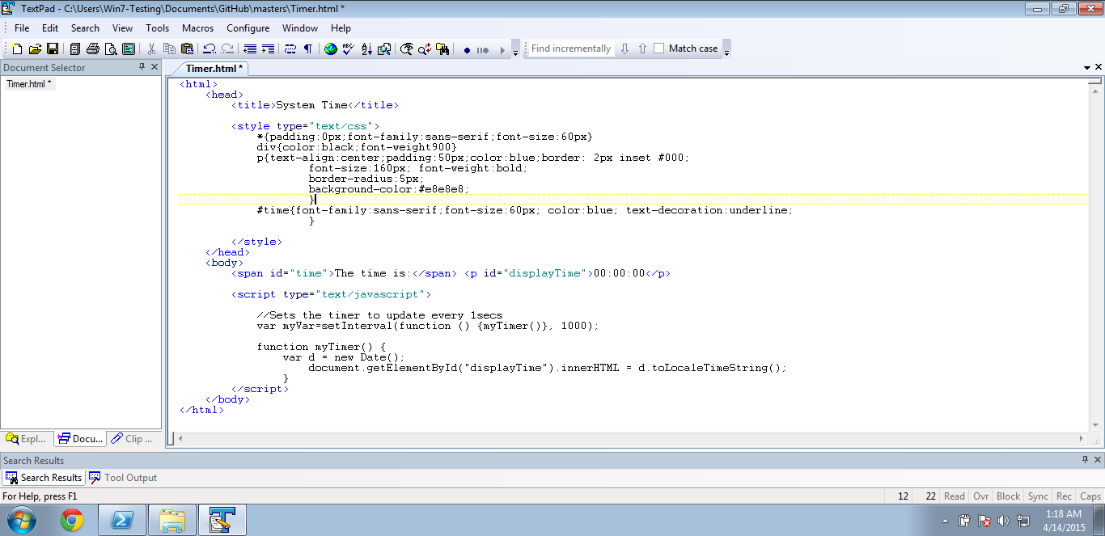

***Timer.html***

Once a member edits this file and wants to synchronize it online. In other words, provide the other team member the updated version of the file, you will type 3 lines of code on the command line.

Git add timer.html + ***press enter key***

Git commit -m “comments on what I changed” + ***press enter key***

Git push + ***press enter key***

That will upload your edited version online for the other team members to see.

**Getting The Updated Version Of A Repository**

To get the updated version of items in the repository, all you need is a line of code.

Git pull + ***press enter key***

That will update the directory with the latest versions of files from the repository online. If there is a conflict in the edited file, you will be alerted and provided with the conflict versions giving you the opportunity to resolve it manually.

3.3) **Working With Repository Using GUI**

In order to use the Graphical User Interface (GUI) version of the GitHub, you will need to find shortcut of the software which named as “*GitHub*” on the desktop section of the computer, and double click on this shortcut as shown in Figure 2.3.



Figure 2.3 : Github Shortcut

After started the GitHub GUI software, log in screen will be displayed on the screen. So that username and password must be entered on this software as shown in Figure 2.4 .

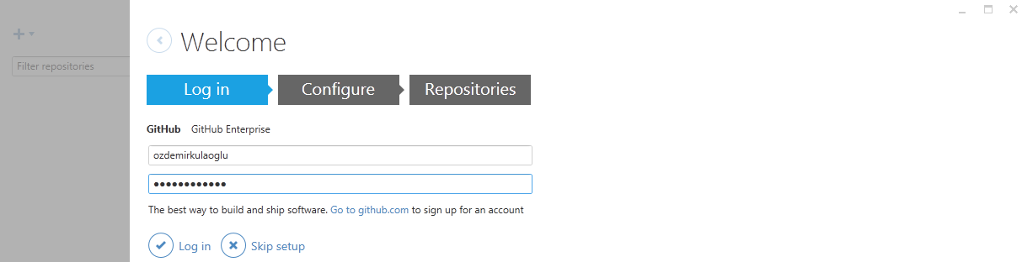

Figure 2.4 : Log In Screen

Having done this, “*Log in*” option must be selected to be logged in to the GitHub environment. When you log in successfully, then you can change your username and email or just leave it as the same thing that appears on the screen. Then, please select continue option to go further. If you do not want to configure your information, skip option must be selected. At the end of these task, you will reached to “*Repositories*” section. Now skip option must be selected which is located at the bottom of the GitHub window.

Having done skip process, GitHub software will be ready to add repository. In order to add repository, there is a blue colored plus sign at the top left corner of the GitHub window. Having done this you will see a window as shown in Figure 2.5 .

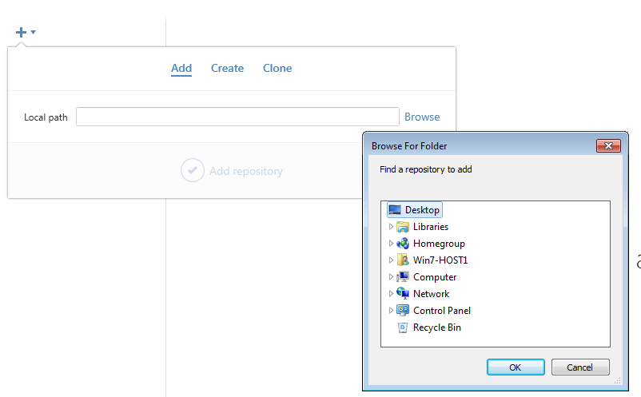

Figure 2.5 : Adding Local Path to GitHub Software

Local path which means that it is a directory that the computer has. So, in order to add a path on the computer, “*Browse*” option must be selected and “*Browse For Folder*” window will be displayed. By using this window, the local path and “*OK”* option must be selected.

In create section, the repository name must be typed and location of the file that is located on the computer must be selected as shown in Figure 2.6 .

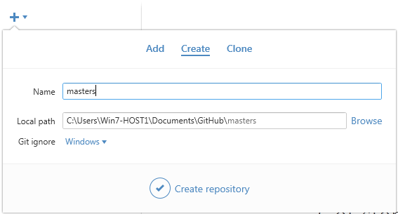

Figure 2.6 : Creating repository

After that “*Create Repository*” option must be selected. In addition, clone section can be used to clone created repository from GitHub web page into GitHub software. Therefore, there will be a list on that screen, only need to select any of those repository to get clones as shown in Figure 2.7 .

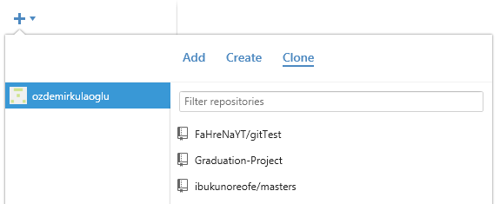

Figure 2.7 : Getting Clones of Repository

When every steps completed successfully, you will have something similar like Figure 2.8 . In this screen, you will have history about files who made changes and also when any file created as a new, then “*uncommitted changes*” part will be changed to committed changes. So summary of the file must be entered and then “*Commit to master”* option must be selected in order to save the changes through GitHub web page and it will be visible by everyone. In addition, to be able to check if any file changed or not, there is “*Sync”* option available at the top right corner of the GitHub software. This option must be selected to see those changes. Therefore, the changed files will come to your computer directory and it is possible to see this information by looking at the “*History*” section of the GitHub software.

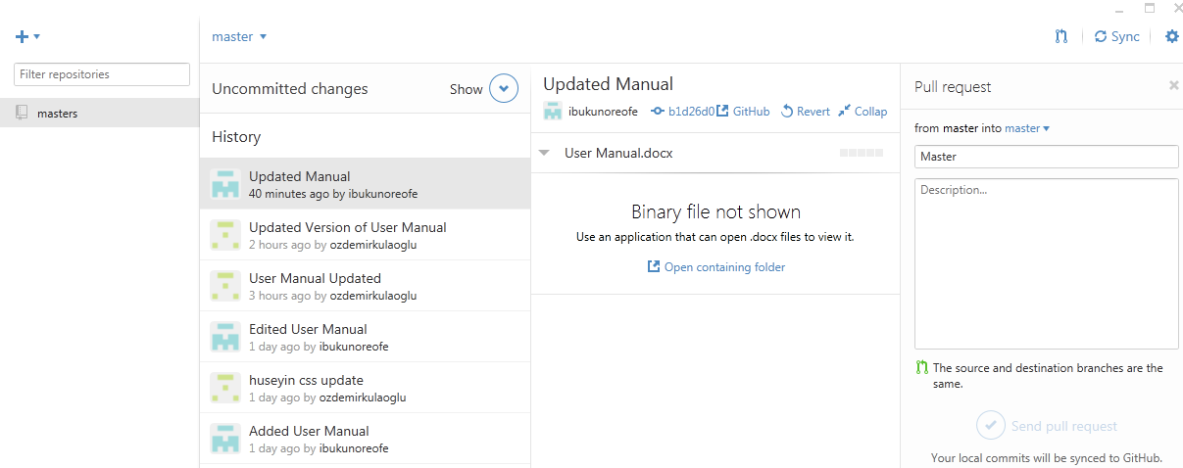

Figure 2.8 : Getting and Sending Updated Files